Lab – Quick Sort Partitioning

For this lab, you will implement the quick sort partitioning algorithm.
Recall that a big part of the quick sort algorithm is partitioning. The goal is to create 2 partitions with the pivot value (p in the image below) placed between them:
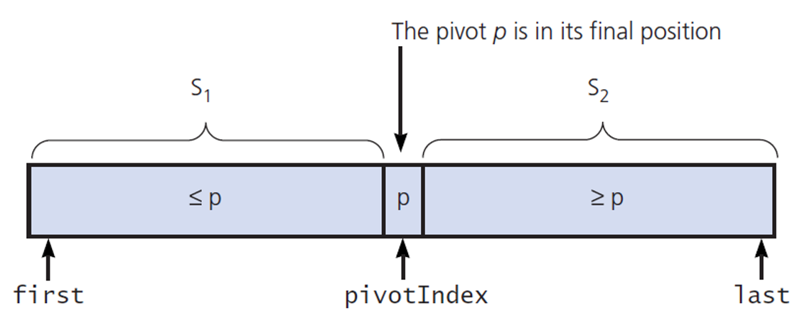
Let’s complete the partition() function. The function receives the array of values (theArray), and indices indicating the range to be partitioned (first and last).
We’ll be following the pseudocode below. The various parts of the implementation will be explained below, but it may be helpful to refer back to this pseudocode.
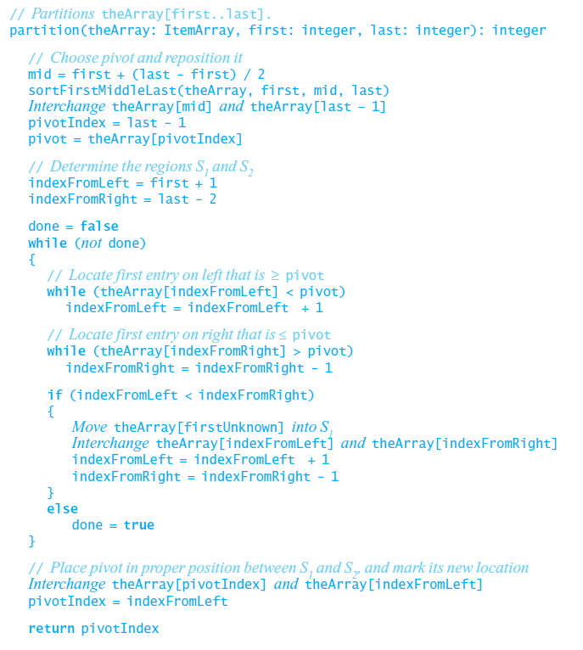

Step 1
The first step after calculating the middle of the range is to apply the median-of-three strategy to select the pivot. This strategy takes the first, middle, and last element of the range, sorts them into ascending order, then uses the middle element as the pivot.
For instance, if the array contained this (omitting all but the first, middle, and last elements):
[13, …, 5, …, 17]
After the median-of-three strategy described above, it would contain:
[5, …, 13, …, 17]
13 would then be selected as the pivot value.
Keep in mind that we’re not necessarily working with all the elements in theArray. first and last tell us the range of the array we’re working with. We won’t access any elements outside that range.
Write the code to accomplish the median-of-three strategy to select the pivot:
- Create a new array containing the first, middle, and last elements of the range to be partitioned. Note those values are in the theArray at index locations first, mid, and last.
- Use the included insertionSort() function to sort the new array of 3 elements from step 1.
- Now that your new 3 element array is sorted, assign its 3 elements in order to theArray’s range’s first, middle, and last elements.
Note that the first, mid, and last values of theArray are now in ascending order (though all the rest of the elements in that range haven’t been touched.) The value at mid is our pivot element.

Step 2
Next, swap the pivot element from the middle of the range to the next-to-last index of the range. With median-of-three we don’t move it to the last index, because we know the value in the last index is larger than the middle index (ie the pivot). So, if the starting array with 13 as the middle/pivot element was:
[5, …, 13, …,2, 17]
After swapping the middle element (i.e. the pivot) with the next-to-last element we would have:
[5, …, 2, …, 13, 17]
Then we set up two indices, one which will move up from the low end of the range, and another to move down from the high end of the range.
Write the code to accomplish this:
- Swap the second to last element to the value of the middle element.
- Set variable pivotIndex to the second to last element index (not the element value).
- Set pivot to the value of the element at pivotIndex in the array.
- Set indexFromLeft to first + 1. We already know the value at index first is less than the pivot due to the median-of-three sorting, so indexFromLeft begins one more than it.
- Set indexFromRight to last - 2. We already know the value at index last is greater than the pivot due to the median-of-three sorting. And we know the pivot is at index last – 1. So indexFromRight begins one less than the pivot index.

Step 3
indexFromLeft should track up from its current location until it reaches the first element >= the pivot value.
Write the code to accomplish this: While the element at indexFromLeft in the array is less than pivot value, increment indexFromLeft by 1.

Step 4
Similarly, indexFromRight should track down from its current location until it reaches the first element <= the pivot value.
Write the code to accomplish this: While the element at indexFromRight in the array is greater than pivot, decrement indexFromRight by 1.

Step 5
As long as indexFromLeft and indexFromRight haven’t reached or passed each other in the array, indexFromLeft is pointing at a value larger than the pivot and indexFromRight is pointing at a value smaller than the pivot. Those two values must swap locations.
On the other hand, if indexFromLeft and indexFromRight have reached or passed each other, we’re nearly done partitioning.
Write the code to accomplish this:
If indexFromLeft is less than indexFromRight:
  - Swap the element at indexFromLeft in the array with the element at indexFromRight in the array.
  - Increment indexFromLeft by 1 and decrement indexFromRight by 1 to prepare for the next iteration of the loop.
- Otherwise, set done to True.

Step 6
When done is True the outermost while loop is finished, and we’ve moved the values larger than the pivot toward the high end of the range, and the values smaller than the pivot toward the low end of the range.
Recall we had moved the pivot value temporarily out of the way to the highest index in the range. Now we need to move the pivot to the appropriate point between those 2 sets of values.
Write the code to accomplish this:
- Swap the element at pivotIndex in the array with the element at indexFromLeft in the array.
- Set pivotIndex to indexFromLeft.
We now have 2 partitions with the pivot between them.

Testing
The quickSort() function itself is already completed. Test your program with the provided main.py and ensure the output is sorted.

Turn In
Upload your completed quicksort.py prior to the due date.

